Health Advice Group

Health Advice Group

Example Company
Street Address: 62 OPL Road
Town/city, postcode: TS 44 TR
Phone: 0161 55554444
Email: healthadvice.co.uk


Contents
Health Advice Group 1
Example Company 1
Overview 3
Business Context 4
C4 Model – Digital Solution Overview 5
Constraints 8
User Environment & Experience 12
Deployment 12
Functional and Non-Functional Requirements 13
Decomposition of Functional Requirements 14
Decomposition of Non-Functional Requirements 17
KPIs and User Acceptance Criteria 19
Justification 20

Overview
The Health Advice Group have proposed a digital solution that can ensure accurate and thorough information that is specifically tailored to the customer and their needs. This information would include weather health effects, weather conditions as well as the possibility for allergies, warnings for other risks such as allergen and give advice on how to manage the extreme weather conditions.

The project will be carried out over 2 weeks and will include 20 office hours for development. Development on the proposed digital solution will begin with front-end development and will be based on the front-end designs provided. The front-end of the digital solution is planned to be completed in 5 hours as it would prove to be beneficial if more time was put into the planning and designing as it can be referred to during the development of the digital solution. The front-end development will be expected to take a significant amount of time and effort as it would include and provide all static data which would be required for the digital solution.

After completion of the front-end development, back-end development will initiate. A database will be included to store data as the bulk of the project will be handling data, specifically for the required personal health tracking tool. An API will be included alongside the database as it is required to access weather and pollen data relevant for the front-end. The back-end development is expected to take 5 office hours to complete.

Lastly, the final aspect to be considered and will be initiated after the completion of back-end development is the accessibility features and will ensure that all elements of the digital solution is human readable such as features and data available. Screen readers must be taken into account, as they would not be able to read content as effectively in comparison. Development for accessibility features is thought to take 6 office hours.

The developed personal health tracking tool will, in particular benefit customers that may struggle from weather and/or ailments related to allergies, therefore aiding in customers by providing information that will help them make informed decisions and avoid being troubled by ailments.

Business Context
Stakeholders

Stakeholder | Relation | Desired Outcome
Customer | The customer will be the main beneficiaries of the project. Customers will take advantage of the developed digital solution. | Customers will expect a functioning service that can be used to access weather data accurately as well as be given advice on allergy risks for a specific time and location.
Health Advice Group | The Health Advice Group is the client as well as the sole investor for the project and will be responsible for the public image, having their brand be labelled as the primary provider of the developed digital solution. | Health Advice Group (the client), will be expecting a high-quality digital solution that can be marketed to gain a positive attention to the company, therefore increasing traffic related to their services as well as maintaining cost efficiency.
Developers | The developers will be the ones to execute the project and will be behind the creation of the developed digital solution, ensuring that all user and client requirements (functional and non-functional) are met. The developers will also be responsible for the maintenance as well as further development for the project as the digital solution continues to expand/exist and receive updates. | The developers will be employees of the project and will be expected to receive monetary gain for the development of the digital solution.

C4 Model – Digital Solution Overview
Legend

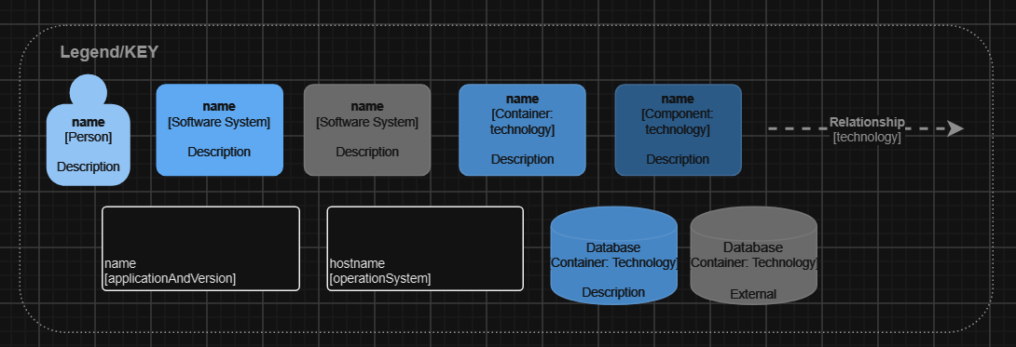
To help viewers keep track of the elements in the model.

Context

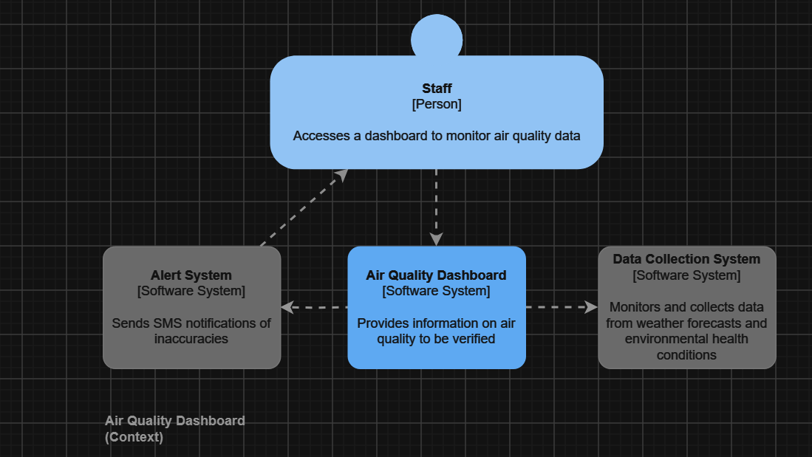

The context level shows a general overview of the software and how it will behave.

Container

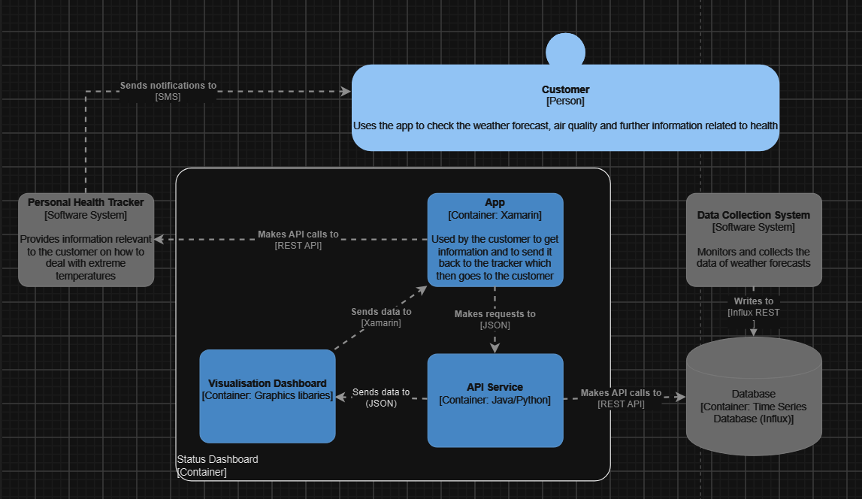

A more in-depth look at how the software will function on the customer’s end in the container level, here the software is making use of the database through the API service and is then sent back to the personal health tracker for the customer to view.

Component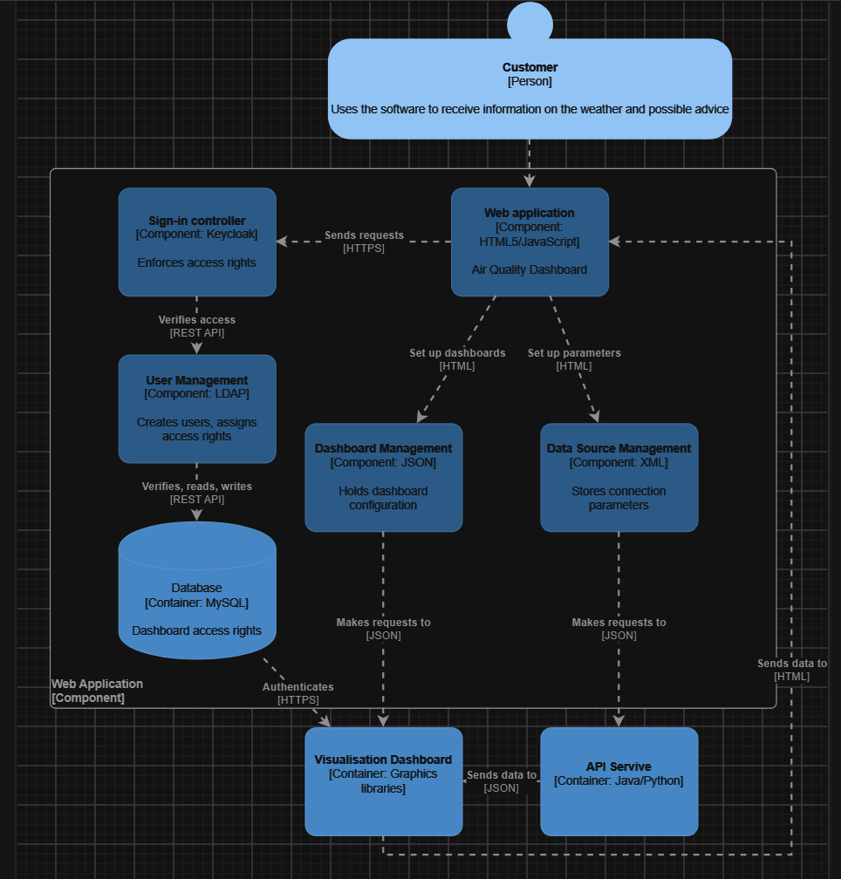

The component level focuses on how the software will function overall which includes the database and API service. The focus of the designs is centred around the usability, user experience as well as accessibility of the software. These aspects are important as they give meaning to the software and reasons for customers to use it over potential competitors.

The key points of the software will be to have a variety of information available and stored in a database, data analysis, research and numerous features for more accessibility and inclusivity.

Class

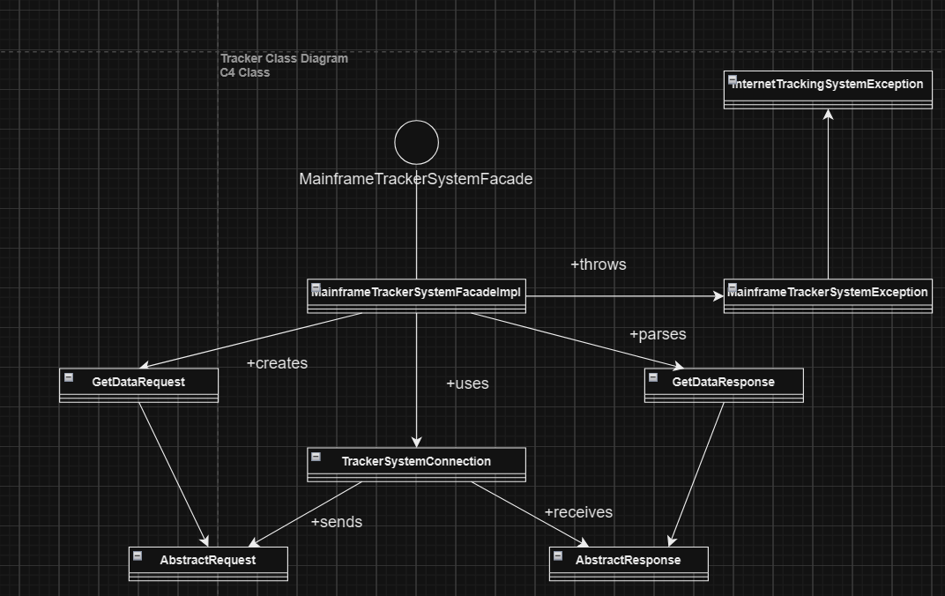

Lastly, the class diagram represents how the overall system will function through the code. As seen above the class diagram shows how the tracker will function through code and how requests are created and responses are parsed for example.

Constraints
Internal Constraints Table

Constraint | Impact of Constraint | Management of Constraint
Cost | The budget of the project has been disclosed as £0. This means all features developed and the services used for development will be free. However, this can restrict resources available to the team when developing the software. | Free services will have to be used as well have all available services be used to their most efficient capability, to ensure that the product is as feature rich and/or flexible as possible.
Scope | Project scope is impacted by cost as well as time available. Considering the resources at the team’s disposal, availability will be restricted, therefore only key features will be mandatory to implement. | Considering the other aspects that limit the project, it should be recommended that key features should be prioritized. If there is time remaining, then accessibility features should be focused on.
Time | For the project, the time available is low amounting to 20 office hours, meaning that the quality of features developed would drop due to the tight time frame. | A timeline should be put in place to bring more structure to the project, if implemented the timeline would give the team the ability to maximise the time spent on core software requirements and ensure that client along with user requirements are met without issue.
Quality | The quality, as discussed in the scope aspect will be heavily restricted due to the funding and time frame provided to the team. Extra features for user experience will not be set as a priority until the other main features are implemented. | All features developed will be of high quality and maximised optimisation, to provide the best user experience that can possibly be given without implementing unnecessary features. If there is time left, then other features can then be focused on.
Resources | The resources used for the project will be greatly limited due to the lack of budget. Resources used must all be free to access therefore limiting the number of quality resources available. Service restrictions may need to be enforced to follow free access of resources. | All resources will need to be maximised and corners would potentially be cut to implement features.

External Constraints Table

Constraint | Impact of Constraint | Management of Constraint
Legislative | Data laws will play a big role in the software’s ability to collect user-based information. The developed software would only be available as a personalised tracker within the UK. In the EU personal data will be stored within the UK and follow GDPR laws. The developed software will have to provide consent forms to determine whether a user consents to their data being used for the software’s purposes before registration to the service provided. | When it comes to registering for personal tracking, it will have to be restricted to users within the EU and the UK.
Security | The project will have to consider that keeping sensitive data securely stored is a top priority. Personal data will be required to provide personalised services included in the software. Thus, authentication as well as encryption (either symmetric or asymmetric) must be included in the development phase to ensure data is safely stored. | Encryption and authentication of sensitive data will be used to establish that all data classified as sensitive is securely stored without the risk of personal data breaches or other potential attacks.
Localisation | As expressed in the brief, the software created will only be available for use in English (UK). This will therefore limit the access of the software internationally and removes the ability to target a wider audience. This is due to the limitations of the time and budget not allowing for the service to be expanded to include such features. | The software will only be available for users in UK English however, there are a variety of tools available that could be used for translation. For now, there is no effective alternative due to other constraints.
Risks | Data that is stored on servers could run the risk of server hardware becoming damaged due to numerous possible issues and would lead to data loss, corruption and breaches. As a result, this would lead to a decrease in customers and an increase in infamy. | There are ways around this constraint, such as transferring data to virtual servers and/or backing up the data to avoid losses. Data breaches can be avoided via encryption as well as authentication.

User Environment & Experience
Customers will access the software via the web, any known web browser will be appropriate as it is important for potential customers to access the software without issue. However, restrictions would potentially occur on older browsers due incompatibility issues from features that require a modern reb browser.

Users will be required to have a network connection to access the software as it is on the web. The software will also be available on any device such as phones and tablets. Features included in the software will be responsive to improve the user experience no matter what the device is. The software developed will be hosted on a server that is accessible via a web browser by users.

Deployment
Deployment of the software will be through a server within the UK and EU. A third-party hosting company will provide the servers and deployment will be started by the development team. Testing will also be carried out by the development team via a deployed environment, the software will be released once the project deadlines are met. A project lifecycle will be put in place to provide direction for team members.

A variety of tests will be done throughout development by following a test plan for the code, to see if all features work as expected. When testing is completed, the system will handle errors that may occur via automation

Functional and Non-Functional Requirements
Functional Requirements Table

ID | Requirement | Mandatory (Y/N)
F1 | Information/data on how to handle severe weather conditions | Y
F2 | Email and password user registration | N
F3 | Personalised health advice based on risk assessment forms | Y
F4 | Personalised health advice on provided health conditions for a given location and time | N
F5 | Weather forecast widgets displayed on an overview dashboard | Y
F6 | Air quality widgets displayed on an overview dashboard | Y
F7 | Links to relevant information based on weather conditions viewable on a weather forecast widget on an overview dashboard | N
F8 | Screen reader accessibility | N
F9 | Information on environmental health conditions | Y
F10 | Tracking trends with weather conditions relevant to a user’s health conditions | N

Decomposition of Functional Requirements
F1

Information explaining on how to manage with extreme weather conditions will be provided as reports in the system. The reports will be accessible through a page displaying all reports set in a list and will allow the user to view them via a link available in the weather forecast widget. The most relevant report to the user will be linked in the widget.

F2

Email and password registration will be required either through a manual email registration which is stored in a database. Emails are stored in plain text and passwords will be hashed, requiring an encryption key if a user attempts to log in. User information will be based on a unique user identifier that will determine their access rights to data within the software.

F3

Risk assessment forms will be provided and would be able to be completed by users who are logged in. The risk assessment form will ask general health questions and collect information that the user inputs. A few health conditions will be listed by default but there will be an option for users to input another condition. The information collected will then be sent to a database and stored by an admin.

F4

A risk assessment form will be able to be completed by users that are logged in. The risk assessment form will ask general health questions as well as provide the option to input a health condition that users are affected by. An array of health conditions will be provided. This will cause a limitation on the ability to provide data for all health conditions. To suffice, an option to input another health condition will be provided. Upon completion of the risk assessment form, reports related to the user’s health condition will be given to the user within the app when their health condition is of concern for a current date in their location.

F5

A weather forecast for the next week will be provided within a widget on the main dashboard. The weather forecast will be displayed as a graph including icons showing the expected weather condition for each day. The graph will also include temperature and humidity.

F6

Air quality for the week will be provided within a widget on the main dashboard. Each day will include an icon that will show tree pollen, weed pollen, grass pollen and air quality. There will also be a rating for the severity of the air quality from good to very poor.

F7

A link to relevant reports about current weather conditions will be provided on the weather forecast widget and the air quality widget. Links will appear when extremer weather conditions occur. When extreme weather conditions take place, a report will be given and includes information on high air quality, and high pollen count. Reports linked will provide advice on how to manage with the weather conditions.

F8

Screen reader accessibility will be ensured through adding alt text to image elements in the software. Headers in the software will be descriptive and precise. Punctuation throughout the software will be checked to ensure that screen readers can read the content with proper grammar.

F9

Information on health conditions will be available as reports in the system. These reports will be accessible through both a page displaying all health condition information reports in a list linked to the navigation bar as well as link available in the air quality and weather forecast widgets that will link to relevant reports for the current air quality/weather conditions.

F10

Previous weather and environment data for a user will be provided as line graphs for users in an expanded trends widget on the dashboard. The type of weather data to show will be chosen by the user with the options being tree pollen count, grass pollen count, weed pollen count, temperature and air quality index for example.

Non-functional Requirements Table

ID | Requirement | Mandatory (Y/N)
NF1 | Average API request speed of below 1 second. | Y
NF2 | Average page rendering speeds below 5 seconds. | Y
NF3 | The software must be able to be accessed on any device with internet access and a browser. | Y
NF4 | The software must be compatible with multiple browsers such as Chrome, Fire Fox, Microsoft Edge and Opera. | Y
NF5 | The software must be available to access 24 hours per day. | Y
NF6 | Screen readers must be able to read all text and describe all images used within the software | Y
NF7 | Colour contrast for headings and images must follow WCAG AAA guidelines | Y
NF8 | Colour contrast for content and text in the application must follow WCAG AA guidelines | Y
NF9 | The software must be written in English and contain no grammatical or spelling errors | Y
NF10 | Navigation between pages must be available in a header bar for large screens as well as a sidebar for small screens. | Y

Decomposition of Non-Functional Requirements
NF1

Average API request speeds will be kept below 5 seconds. This is to ensure that data is returning quickly from APIs and users will not have to wait long periods of time to view data. API requests will be cached when a user makes one for a certain amount of time to be determined by developers. API calls will also avoid including large amounts of adjustment before being returned to the client. Formatting API data will be done on the client side.

NF2

Average page rendering speeds will be kept below 5 seconds as to ensure a quick and pleasant user experience. Average rendering speeds will guarantee this by statically generating pages wherever possible so that they don’t have to be rendered client side making rendering sufficiently fast.

NF3

Responsive designs will be implemented to ensure all screen-sizes are able to be used for the software. Menus will be included for easy navigation when small screen sizes are being used. Touch will be checked on all aspects for the software to ensure all features can be used efficiently by users.

NF4

Modern browsers will be the focus when developing the software as legacy browsers are not in high demand. This will not need much time to develop and test as modern browsers often support all the same features. The software will be tested on different browsers such as Opera, Chrome, Safari and Mozilla Fire Fox to ensure all features work effectively and any issues that occur can be dealt with.

NF5

The software will be deployed on servers that will be running 24/7 and backup servers will be provided so if any issues occur on one server than the software is able to start back up on a different server securely.

NF6

All images and text will be easily readable by screen readers. Images will be included with alt text in their element to ensure that all images can be described by screen readers. All text included in the software will be checked for proper grammar and punctuation to avoid confusion with wording when using a screen reader.

NF7

Header text and branding text will be kept in a 14pt or higher font size, will be in bold and have a contrast ratio of 4:5:1 to follow the AAA WCAG Guidelines for better accessibility of headers. Images and graphical objects will include a contrast ratio of 3:1 so that everything is clearly visible.

NF8

Content text will be 9pt or higher font size and have a contrast ratio of 4:5:1. The primary focus will be on text within blocks of text, user interface components will have a contrast ratio of 3:1 and graphical objects will either include a contrast of 3:1 or descriptive text with a contrast ratio of 4:5:1.

NF9

Developers will be fully proficient in UK English and grammar will be peer checked by AI and a reviewer to ensure that all grammar is correct.

NF10

Navigation will be clearly displayed to users at the top of each page so that users can access the navigation bar included with ease. Labels will be descriptive and short to ensure users gain a basic understanding of what each page is without needing to click and check them.

KPIs and User Acceptance Criteria
A target code churn KPI will be included and measured throughout the project with the code churn targets becoming stated once the graph is complete. Target code churn percentages are decided by the amount of functionality that needs to be developed for the day based on a Gantt Char that will be provided in the design document.

User Requirement | Acceptance Criteria
A user should be able to see an air quality forecast to inform them on health decisions. | - A link to reports providing relevant health about current air quality conditions.  - Information on air quality index displayed on the widget.  - Information on pollen will be displayed on the widget.  - A widget that displays the next week’s air quality forecast on a dashboard.
A user must be able to weather forecast to inform on health decisions. | - Ability to expand weather forecast widgets with individual days hourly forecasts.  - Links to relevant reports explaining health information on current weather conditions.  - A widget that displays the next week’s weather forecast on a dashboard.
A user should have personalised health advice based on location. | - Linking to relevant health reports based on weather conditions in inputted location via dashboard widgets.  - Ability to enter manual locations to measure the weather and environmental conditions at that location.
A user should be able to get advice on how to manage their health related to weather/environment conditions. | - Linking to relevant resources when weather conditions or environmental conditions on the dashboard are of concern via the dashboard widget.  - Reports with accurate and correct information that can be accessed through the application by a user.

Justification
The health advice group project will be built in HTML, CSS, JS and SQL with the frameworks included being ReactJS. Visual Studio Code will be used to provide static site generation meaning pages can be rendered and other pieces of code relevant to the software can be executed. Accessing static sites will be very rapid and will provide a good user experience. Static site generation however will only be provided to the resource pages as the rest will include dynamic data for users. Navigation due to this decision will be efficient and allow for users to access necessary resources and advice with minimal delay.

ReactJS is a widely known and used framework for developing modern web applications. ReactJS provides custom components to be developed that can be implemented into files with ease. It will allow for efficient code creation and to avoid large files that would be difficult to read. ReactJS sufficiently expandable and will for plenty of future updates/developments to occur whenever the client requires it to.

Tailwind CSS will be implemented to develop the CSS for the application. Tailwind CSS is a well-known CSS framework that includes clean designs and can help speed up CSS development. This will allow for easier understanding of the code base for developers when updates are required by the client.

The homepage will contain a more simplified version of the dashboard page allows for users to access information efficiently when in depth reviews of information is not required by the users. In the dashboard, It will include the next week’s weather forecast as well as air quality averages without having to navigate the web application. Implementing this feature will allow for an increased user experience and customer retention as users will find the web application more convenient to use.

Weather and air quality monitoring widgets on the home page will not display hourly averages for a specific day when clicked, instead a link to the dashboard will be given as the time required to render on the home page would increase in comparison and will also reduce strain on the API requests. A fast loading application is of high importance as to not frustrate users when they try to use the application solely for a specific purpose.

Lastly, the trends, air quality and weather forecast widgets will displayed on the dashboard and will provide graphs, information relevant to the user as well as links to reports for more in-depth information to provide users with the best information available to them and improve the user experience to further improve user retention.

